**DBMS - Mini Project**

**Organ Donation and Procurement Management System**

Submitted By:

Name :Preethika Ajay Kumar

SRN : PES2UG20CS256

V Semester Section D

**Short Description and Scope of the Project**

Organ donation and procurement plays a crucial role in improving the lives of patients worldwide. One main problem that is present today is the fact that organs are not available in time to save patients’ lives. This system uses database technologies to manage a person’s donation of organs. Organ procurement facilities are also enlisted. The database will be designed to maintain a complete medical record of all patients, along with information based on geographic location. These features will enable easy procurement for patients in time of need.

**ER Diagram**

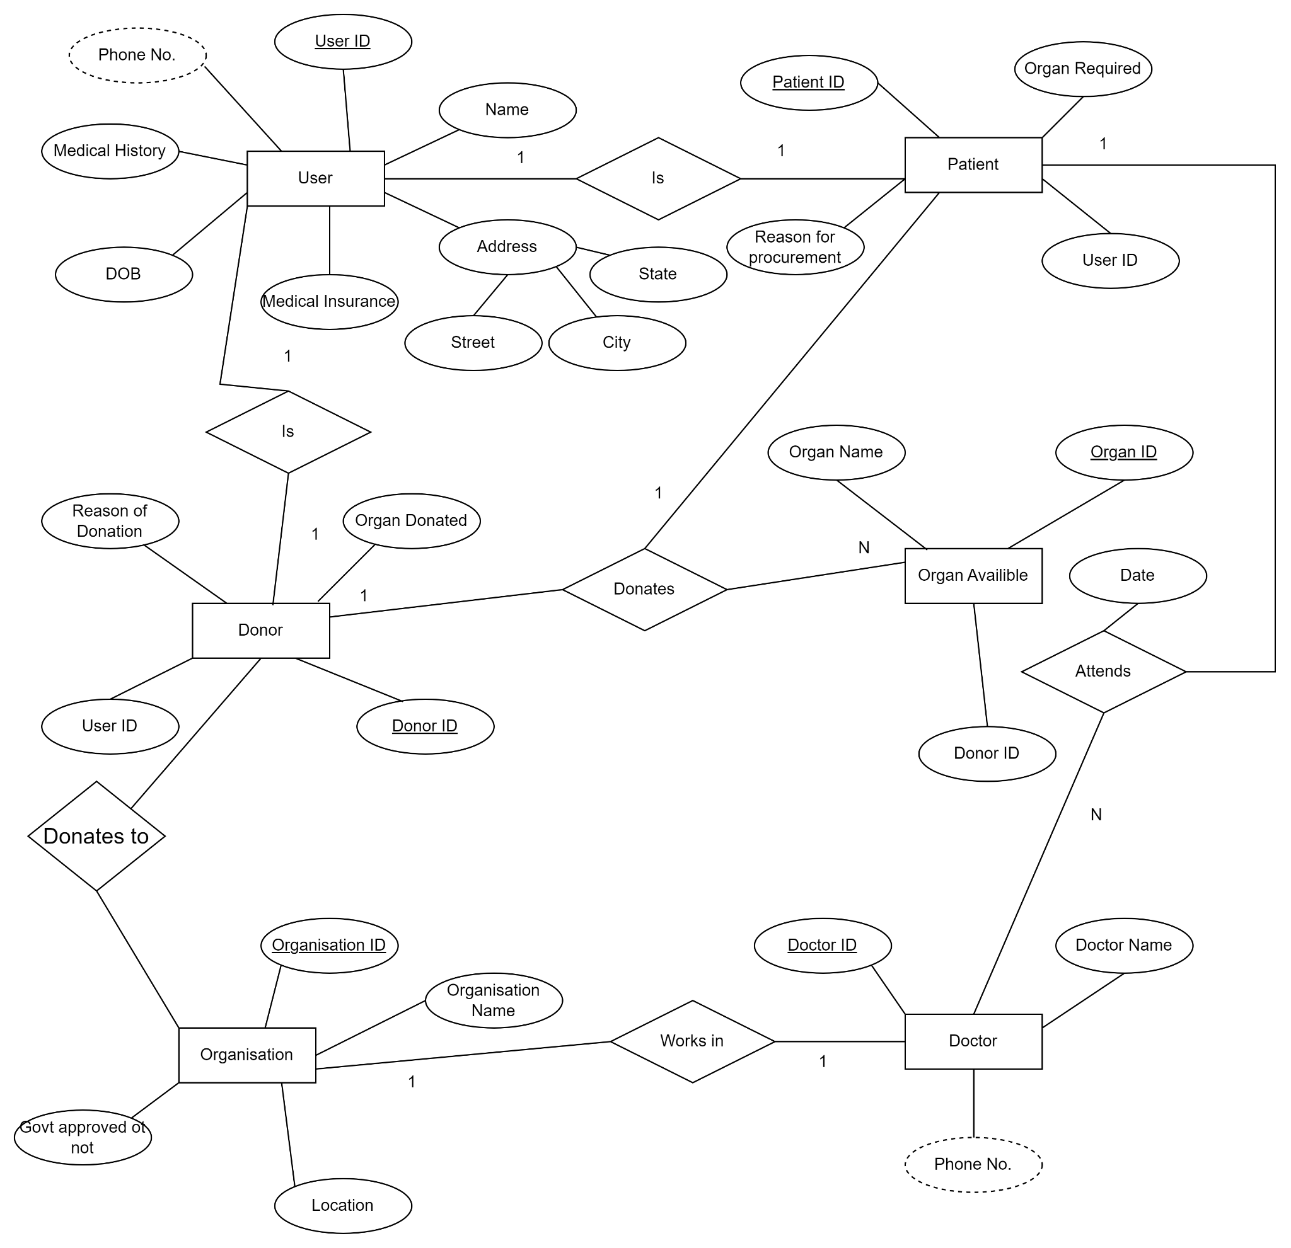

**Relational Schema**

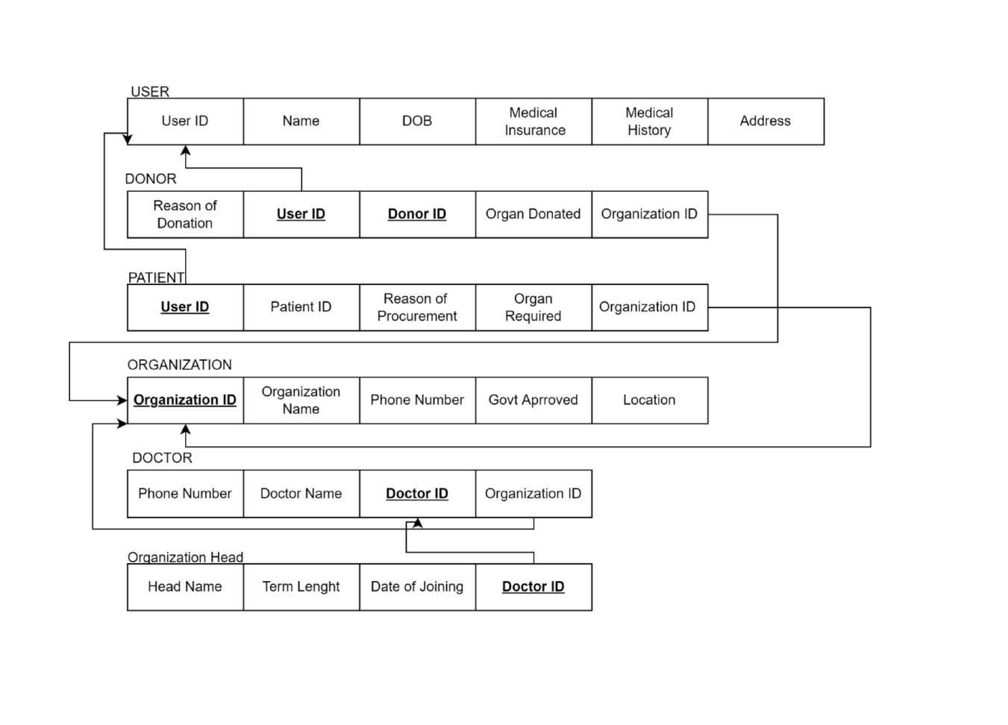

**DDL statements - Building the database**

CREATE DATABASE DBMS_proj_final;

USE DBMS_proj_final;

#table 1

CREATE TABLE User(

User_ID int NOT NULL,

Name varchar(20) NOT NULL,

Date_of_Birth date NOT NULL,

Medical_insurance int,

Medical_history varchar(20),

Street varchar(20),

City varchar(20),

State varchar(20),

Phno_user varchar(10),

PRIMARY KEY(User_ID)

);

#table 2

CREATE TABLE Organization(

Organization_ID int NOT NULL,

Organization_name varchar(20) NOT NULL,

Location varchar(20),

Government_approved int, # 0 or 1

PRIMARY KEY(Organization_ID)

);

#table 3

CREATE TABLE Doctor(

Doctor_ID int NOT NULL,

Doctor_Name varchar(20) NOT NULL,

organization_ID int NOT NULL,

FOREIGN KEY(organization_ID) REFERENCES Organization(organization_ID) ON DELETE CASCADE,

PRIMARY KEY(Doctor_ID)

);

#table 4

CREATE TABLE Patient(

Patient_ID int NOT NULL,

organ_req varchar(20) NOT NULL,

reason_of_procurement varchar(20),

Doctor_ID int NOT NULL,

User_ID int NOT NULL,

FOREIGN KEY(User_ID) REFERENCES User(User_ID) ON DELETE CASCADE,

FOREIGN KEY(Doctor_ID) REFERENCES Doctor(Doctor_ID) ON DELETE CASCADE,

PRIMARY KEY(Patient_Id, organ_req)

);

#table 5

CREATE TABLE Donor(

Donor_ID int NOT NULL,

organ_donated varchar(20) NOT NULL,

reason_of_donation varchar(20),

Organization_ID int NOT NULL,

User_ID int NOT NULL,

FOREIGN KEY(User_ID) REFERENCES User(User_ID) ON DELETE CASCADE,

FOREIGN KEY(Organization_ID) REFERENCES Organization(Organization_ID) ON DELETE CASCADE,

PRIMARY KEY(Donor_ID, organ_donated)

);

#table 6

CREATE TABLE Organ_available(

Organ_ID int NOT NULL AUTO_INCREMENT,

Organ_name varchar(20) NOT NULL,

Donor_ID int NOT NULL,

FOREIGN KEY(Donor_ID) REFERENCES Donor(Donor_ID) ON DELETE CASCADE,

PRIMARY KEY(Organ_ID)

);

**Populating the Database**

insert into Organization values

(1, 'Organization-1','New Delhi',1),

(2, 'Organization-2','Mumbai',0),

(3, 'Organization-3','Kolkata',0),

(4, 'Organization-4','Kolkata',1),

(5, 'Organization-5','Ahmedabad',1),

(6, 'Organization-6','Kolkata',0),

(7, 'Organization-7','Kolkata',0),

(8, 'Organization-8','Ahmedabad',0),

(9, 'Organization-9','Kolkata',1),

(10, 'Organization-10','Ahmedabad',1),

(11, 'Organization-11','Ahmedabad',1),

(12, 'Organization-12','Mumbai',0),

(13, 'Organization-13','Kolkata',0),

(14, 'Organization-14','Ahmedabad',1),

(15, 'Organization-15','Ahmedabad',0);

insert into Doctor values

(1,'Doctor-1',12),

(2,'Doctor-2',10),

(3,'Doctor-3',1),

(4,'Doctor-4',6),

(5,'Doctor-5',11),

(6,'Doctor-6',9),

(7,'Doctor-7',5),

(8,'Doctor-8',4),

(9,'Doctor-9',7),

(10,'Doctor-10',3),

(11,'Doctor-11',8),

(12,'Doctor-12',2),

(13,'Doctor-13',13),

(14,'Doctor-14',15),

(15,'Doctor-15',14);

insert into User values

( 1 ,'Name-1','1978-8-21',1,'NIL','Street-1','New Delhi','Delhi', '1212121212'),

( 2 ,'Name-2','1975-12-10',0,'NIL','Street-2','Mumbai','Maharashtra', '2121212121'),

( 3 ,'Name-3','1976-6-4',0,'NIL','Street-3','Mumbai','Maharashtra', '2323232323'),

( 4 ,'Name-4','1985-10-13',1,'NIL','Street-4','Ahmedabad','Gujarat', '3232323232'),

( 5 ,'Name-5','1983-10-12',1,'NIL','Street-5','Kolkata','West Bengal', '3434343434'),

( 6 ,'Name-6','1977-1-18',1,'NIL','Street-6','Kolkata','West Bengal', '4343434343'),

( 7 ,'Name-7','1976-2-26',0,'NIL','Street-7','New Delhi','Delhi', '4545454545'),

( 8 ,'Name-8','1973-4-12',1,'NIL','Street-8','Mumbai','Maharashtra', '5454545454'),

( 9 ,'Name-9','1976-11-1',0,'NIL','Street-9','Mumbai','Maharashtra', '5656565656'),

( 10 ,'Name-10','1978-11-18',1,'NIL','Street-10','New Delhi','Delhi', '6565656565'),

( 11 ,'Name-11','1975-1-6',1,'NIL','Street-11','Mumbai','Maharashtra', '6767676767'),

( 12 ,'Name-12','1983-11-1',1,'NIL','Street-12','Mumbai','Maharashtra', '7676767676'),

( 13 ,'Name-13','1983-1-9',1,'NIL','Street-13','New Delhi','Delhi', '7878787878'),

( 14 ,'Name-14','1975-10-12',1,'NIL','Street-14','Mumbai','Maharashtra', '8787878787'),

( 15 ,'Name-15','1977-9-23',0,'NIL','Street-15','Ahmedabad','Gujarat', '8989898989');

insert into Patient values

(1,'Heart','Reason-1',3,12),

(2,'Kidney','Reason-2',2,13),

(3,'Pancreas','Reason-3',7,8),

(4,'Kidney','Reason-4',8,7),

(5,'Heart','Reason-5',4,11),

(6,'Lung','Reason-6',1,14),

(7,'Intestine','Reason-7',10,5),

(8,'Intestine','Reason-8',12,3),

(9,'Lung','Reason-9',11,4),

(10,'Kidney','Reason-13',6,9),

(11,'Kidney','Reason-11',9,6),

(12,'Pancreas','Reason-12',5,10),

(13,'Intestine','Reason-13',13,2),

(14,'Heart','Reason-14',14,1),

(15,'Kidney','Reason-15',15,15);

insert into Donor values

(1,'Heart','Reason-1',7,8),

(2,'Pancreas','Reason-2',9,6),

(3,'Pancreas','Reason-3',1,14),

(4,'Intestine','Reason-4',6,9),

(5,'Kidney','Reason-5',8,7),

(6,'Pancreas','Reason-6',2,13),

(7,'Kidney','Reason-7',5,10),

(8,'Kidney','Reason-8',3,12),

(9,'Heart','Reason-9',15,15),

(10,'Heart','Reason-10',4,11),

(11,'Kidney','Reason-11',11,4),

(12,'Pancreas','Reason-12',4,12),

(13,'Pancreas','Reason-13',12,3),

(14,'Pancreas','Reason-14',10,5),

(15,'Heart','Reason-15',5,4),

(16,'Intestine','Reason-16',14,1),

(17,'Intestine','Reason-17',13,2),

(18,'Intestine','Reason-18',2,7),

(19,'Pancreas','Reason-19',9,9),

(20,'Intestine','Reason-20',1,2);

insert into organ_available values

(1,'Heart',9),

(2,'Pancreas',4),

(3,'Pancreas',5),

(4,'Intestine',6),

(5,'Kidney',12),

(6,'Pancreas',8),

(7,'Kidney',3),

(8,'Kidney',11),

(9,'Heart',1),

(10,'Heart',10),

(11,'Kidney',13),

(12,'Pancreas',2),

(13,'Pancreas',7),

(14,'Pancreas',14),

(15,'Heart',15),

(16,'Intestine',3),

(17,'Intestine',9),

(18,'Intestine',7),

(19,'Pancreas',6);

**Join Queries**

Showcase at least 4 join queries

Write the query in English Language, Show the equivalent SQL statement and also a screenshot of the query and the results

Join of Organ_available and Donor, so as to get all the organs donated by a donor along with organ_id

**select Donor.Donor_ID, Donor.organ_donated, Donor.reason_of_donation, organ_available.Organ_ID from donor inner join organ_available on Donor.Donor_id = organ_available.donor_id;**

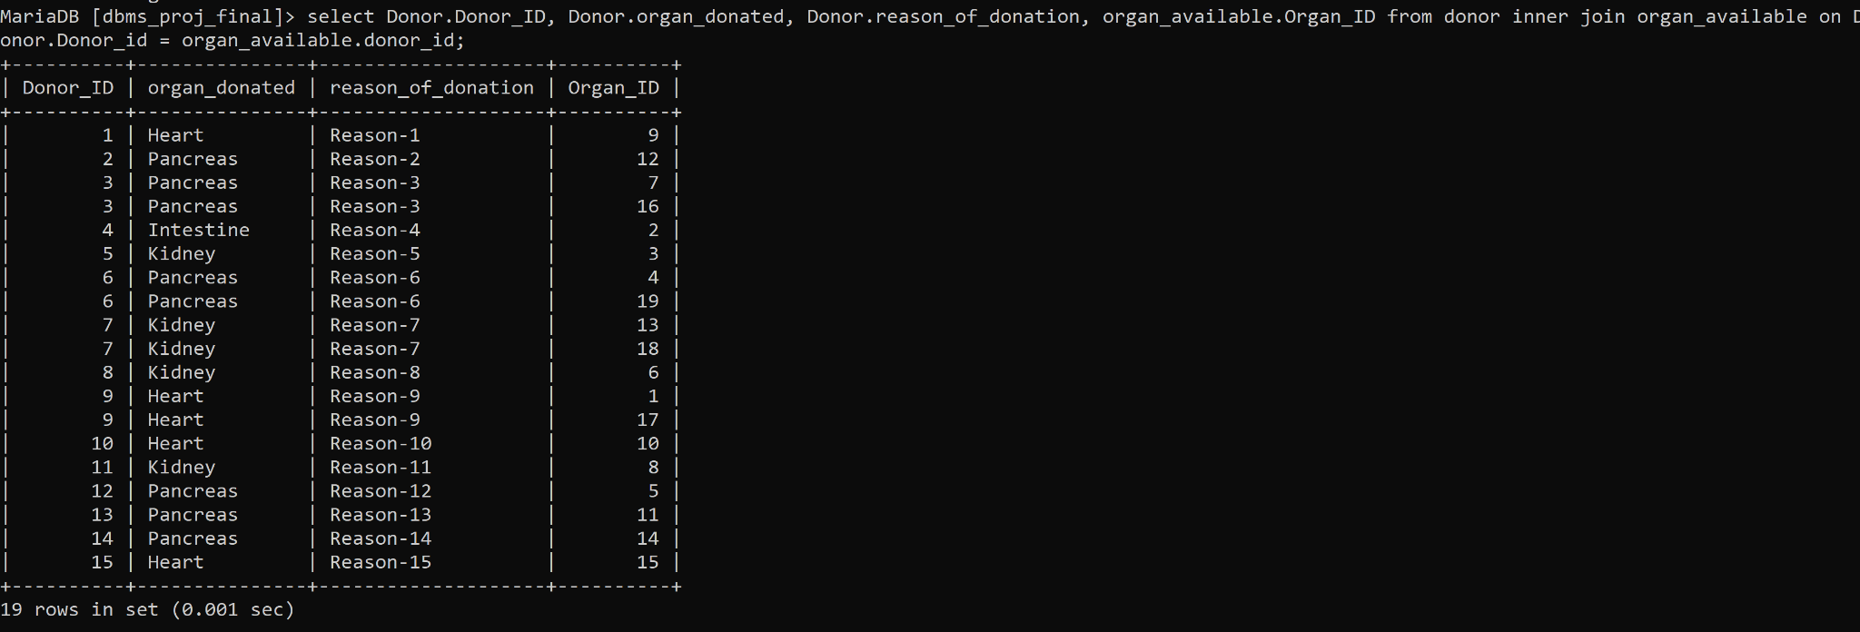

Join to find the location where the donor has donated the organ.

**select organization.Organization_id, organization.organization_name, organization.location, organization.government_approved, donor.organ_donated, donor.reason_of_donation from organization inner join donor on donor.organization_id = organization.organization_id;**

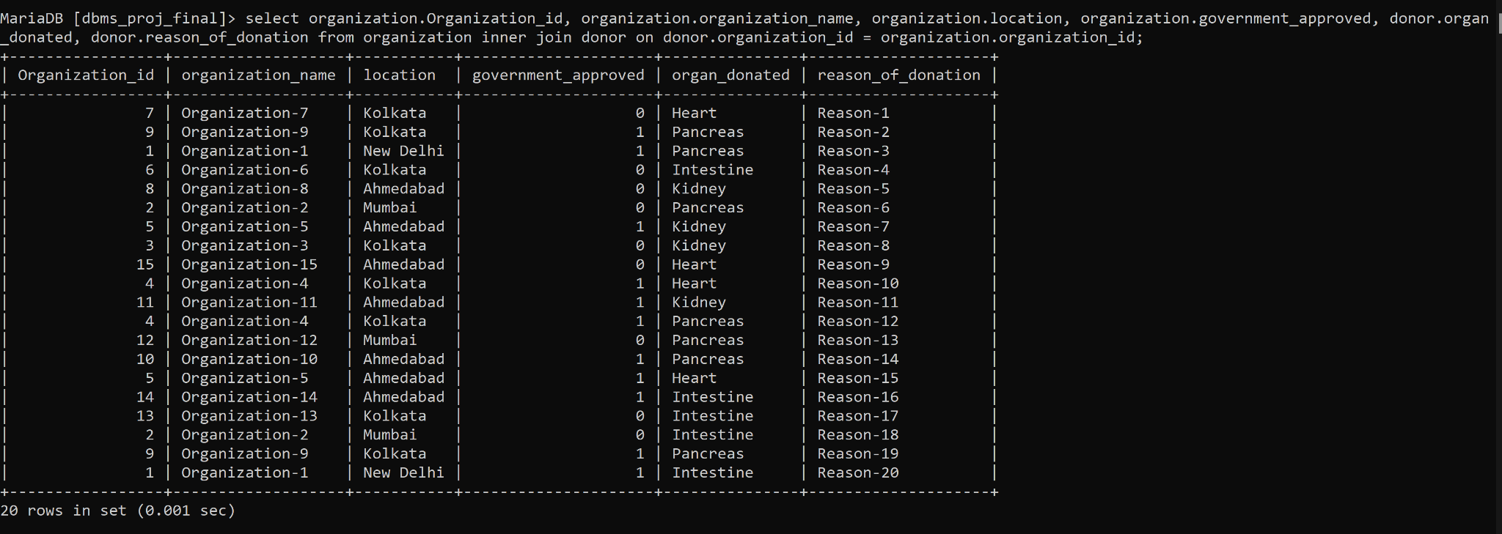

**Aggregate Functions**

Showcase at least 4 Aggregate function queries

Write the query in English Language, Show the equivalent SQL statement and also a screenshot of the query and the results

To get the count of number of users that have medical insurance:

**select count(medical_insurance) from user where medical_insurance = 1;**

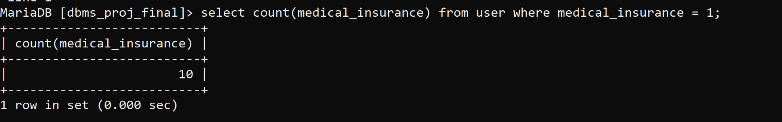

To select the organ which has maximum number of available units for donation

**select max(y.num), y.organ_name from (select count(*) as num , organ_name from organ_available group by organ_name)y;**

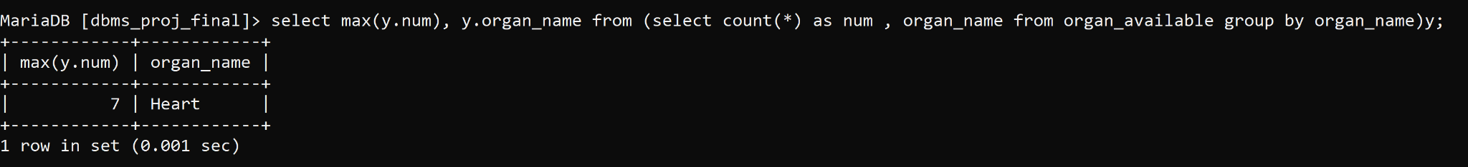

**Set Operations**

Showcase at least 4 Set Operations queries

Write the query in English Language, Show the equivalent SQL statement and also a screenshot of the query and the results

List of Donors and Patients

**select * from patient union all select * from donor;**

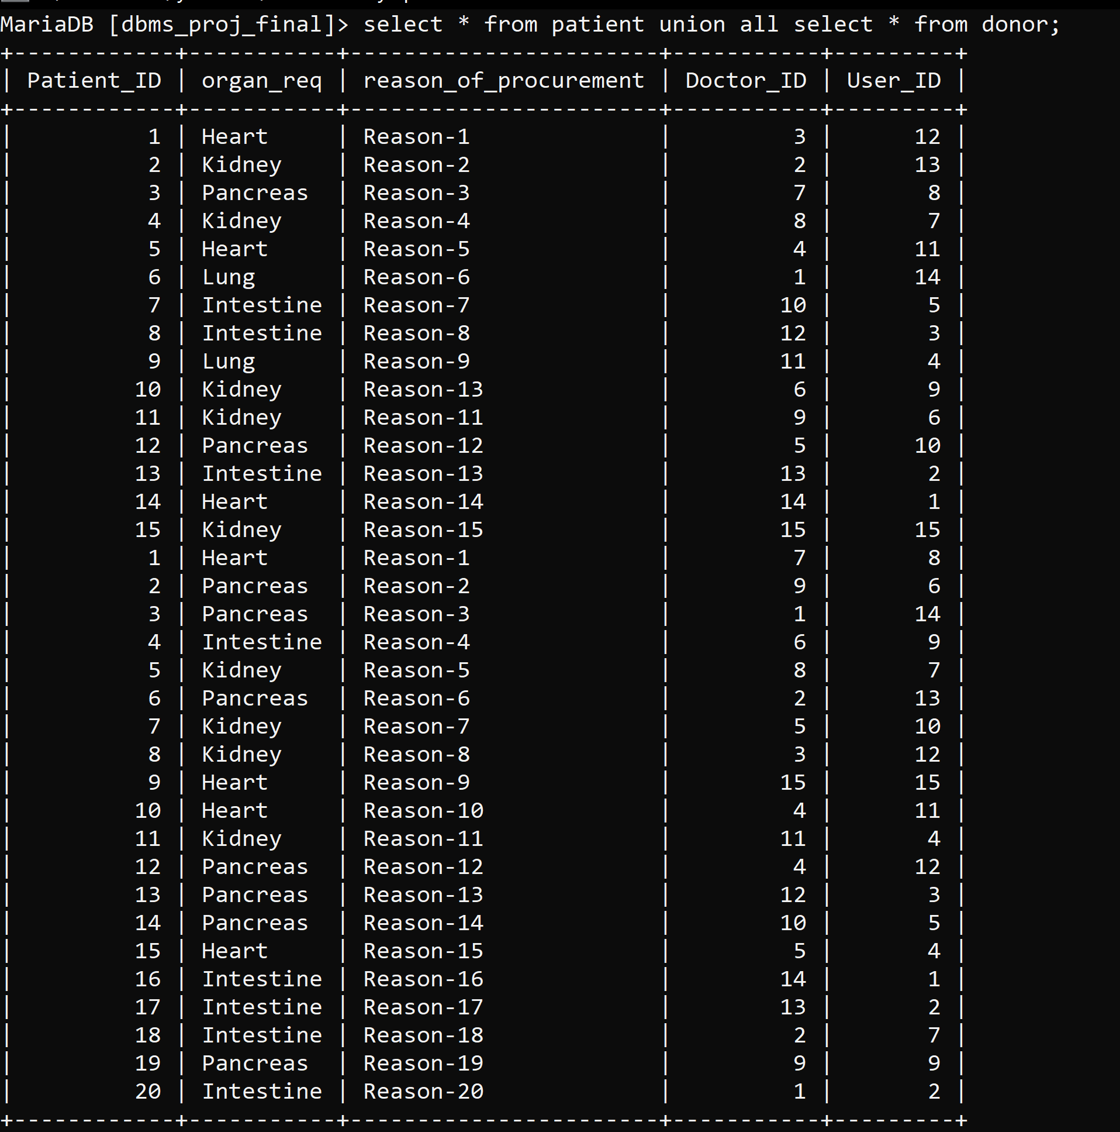

Union of doctor and organ_available

**select * from doctor union all select * from organ_available;**

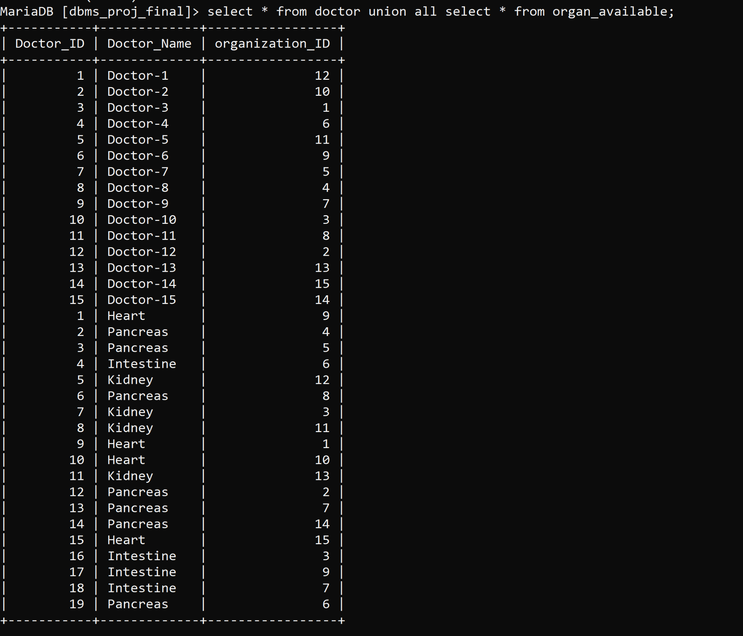

**Functions and Procedures**

Create a Function and Procedure. State the objective of the function / Procedure. Run and display the results.

**DELIMITER //**

**CREATE PROCEDURE get_loc()**

**BEGIN**

**SELECT donor.organ_donated, organization.organization_name, organization.location FROM donor INNER JOIN organization ON donor.organization_id=organization.organization_id;**

**END;**

**//**

**DELIMITER;**

**CALL get_loc()**

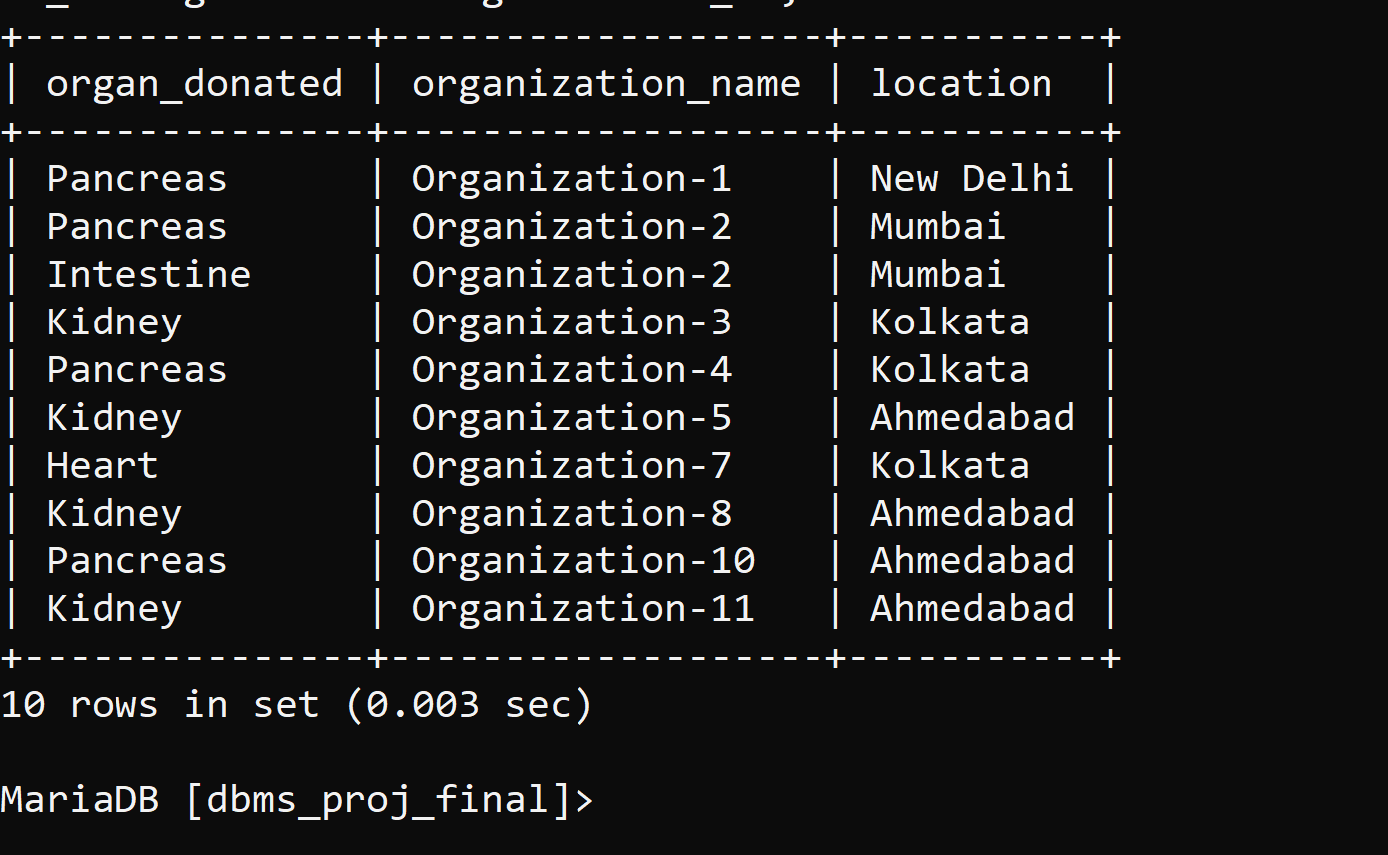

**Triggers and Cursors**

Create a Trigger and a Cursor. State the objective. Run and display the results.

Trigger to get a insert name of users with medical insurance into another table.

**delimiter |**

**CREATE TRIGGER med_ins BEFORE INSERT ON user**

**FOR EACH ROW**

**BEGIN**

**IF NEW.medical_insurance = 1 THEN**

**INSERT INTO med_insurance SET name = NEW.name;**

**END IF;**

**END;**

**|**

**delimiter ;**



**Developing a Frontend**

The frontend should support

1. Addition, Modification and Deletion of records from any chosen table 2. There should be an window to accept and run any SQL statement and display the result

